Weitere
besondere
PUNKTE

Punkte auf der EULER-Geraden

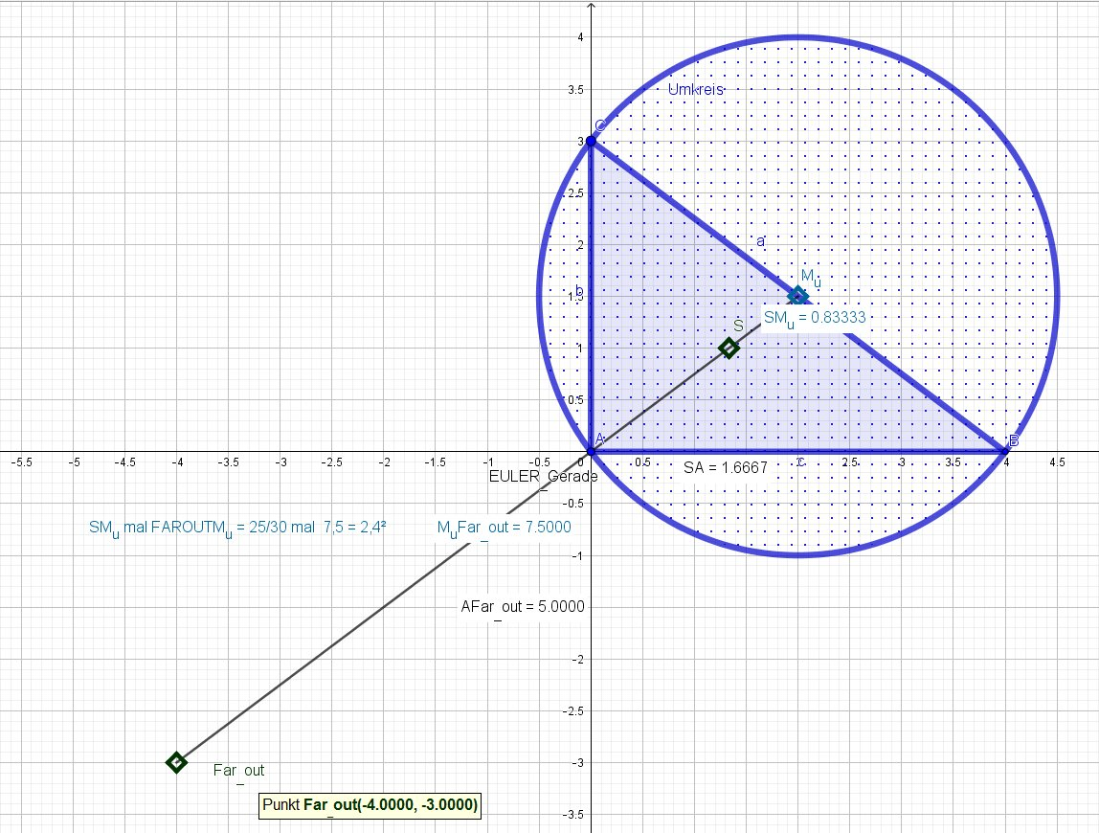

Der Far-out-Punkt ist das am Umkreis gespiegelte Bild des Schwerpunkts S.

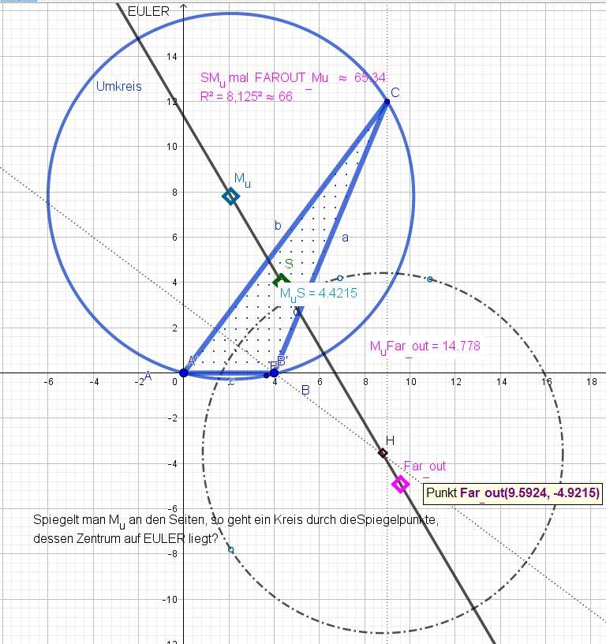

SCHIFFLERpunkt

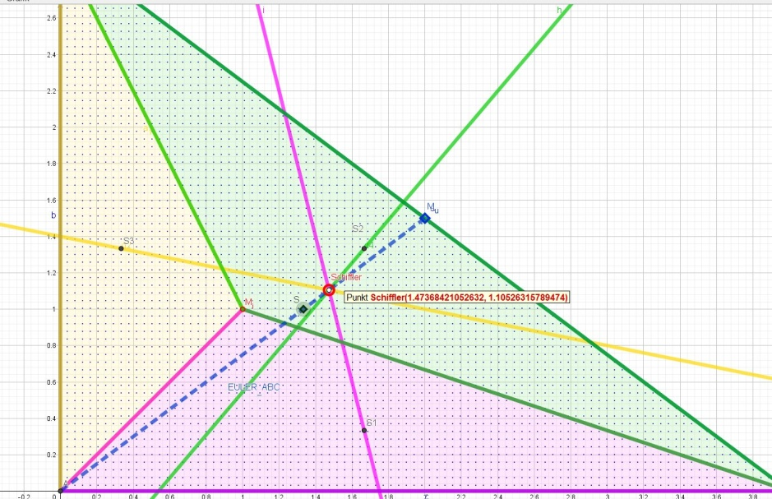

Die Inkreismitte bildet mit den Ecken Dreiecke, deren Eulergeraden sich im Schiffler-Punkt schneiden. Er liegt auch auf der Eulergeraden vom ∆ABC.

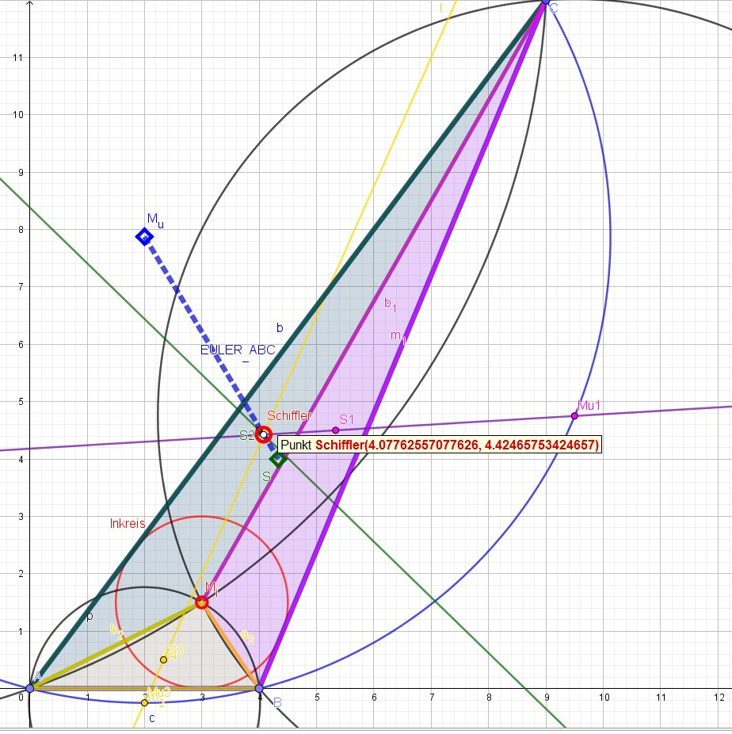

ZUSATZ:

Die ersten vierzig mit X durchnummerierten Punkte des >>Kimberlin Triangle Centers<<

X1=M_{i} Inkreismitte

X2=S Schwerpunkt

X3=M_{u} Umkreismitte

X4=H Höhenschnitt

X5= M_{F} Feuerbachkreismitte (9-Punkte-Zentrum)

X(6)=SYMMEDIAN Punkt
(LEMOINE POINT, GREBE POINT)

Schwerpunkt des H-Fußdreiecks; Musterbeispiel für den isogonal transformierten Schwerpunkt = X2

X(7)= GERGONNE POINT

X(8)=NAGEL POINT
Der ISOTOMISCH transformierte X7 = Gergonne-Punkt! Symmedian des Ankreismittendreiecks
{ X(6)-of-the-excentral-triangle, A'B'C'}

X(10)=SPIEKER CENTER

X(11)=FEUERBACH POINT

X(12)= {X(1),X(5)}-HARMONIC CONJUGATE OF X(11)

X(13)=1st ISOGONIC CENTER=1.FERMAT POINT

(oder auch TORRICELLI POINT)

X(14)=2nd ISOGONIC CENTER= 2.FERMAT POINT

(oder auch TORRICELLI POINT)

X(15)=1st ISODYNAMIC POINT

X(16)=2nd ISODYNAMIC POINT

X(17)=1st NAPOLEON POINT

X(18)=2nd NAPOLEON POINT
X(19) = CLAWSON POINT Although John Clawson studied this point in 1925, it was studied earlier by Lemoine: Emile Lemoine, "Quelques questions se rapportant à l'étude des antiparallèles des côtes d'un triangle", Bulletin de la S. M. F., tome 14 (1886), p. 107-128, specifically, on page 114. This article is available online at Numdam.

X(20)=DE LONGCHAMPS POINT

X(21)=SCHIFFLER POINT

X(22)=EXETER POINT a point on the Euler line

X(23)=FAR-OUT POINT a point on the Euler line http://mathworld.wolfram.com/Far-OutPoint.html

X(24)=PERSPECTOR OF ABC AND ORTHIC-OF-ORTHIC TRIANGLE a point on the Euler line

.

X(25)=HOMOTHETIC CENTER OF ORTHIC AND TANGENTIAL TRIANGLES a point on the Euler line
Constructed as indicated by the name; also X(25) is the pole of the orthic axis with respect to the circumcircle.

X(26)=CIRCUMCENTER OF THE TANGENTIAL TRIANGLE
a point on the Euler line

X(27)=CEVAPOINT OF ORTHOCENTER AND CLAWSON CENTER
a point on the Euler line

X(28)=CEVAPOINT OF X(19) AND X(25)
point on the Euler line .

X(29)=CEVAPOINT OF INCENTER AND ORTHOCENTER

X(30)=EULER INFINITY POINT
X(30) is the point of intersection of the Euler line and the line at infinity. Euler Infinity Point.

X(31)=2nd POWER POINT

X(32)=3rd POWER POINT
The 5th Brocard triangle is here introduced as the vertex triangle of the circumcevian triangles of the 1st and 2nd Brocard points. (Randy Hutson, December 26, 2015)

X(33)=PERSPECTOR OF THE ORTHIC AND INTANGENTS TRIANGLES

X(34)=X(4)-BETH CONJUGATE OF X(4)

X(35)={X(1),X(3)}-HARMONIC CONJUGATE OF X(36)

X(36)=INVERSE-IN-CIRCUMCIRCLE OF INCENTER

X(37)=CROSSPOINT OF INCENTER AND CENTROID

X(39)=BROCARD MIDPOINT

X(40)=BEVAN POINT ( ich nenne ihn M_{i}_Tan )
mentioned in a problem proposal by Benjamin Bevan, published in Leybourn's Mathematical Repository, 1804, p. 18.

X20
X21 EXETER= X22

